Student’s name | …………………………………………………….…… | Grade | 1
Subject | Computer | Week No. | 7
Lesson Title | Click with Mouse | Unit
Worksheet No. ( 7 ) (Answer)
Instruction: Color the

Color the left click
Color the right click
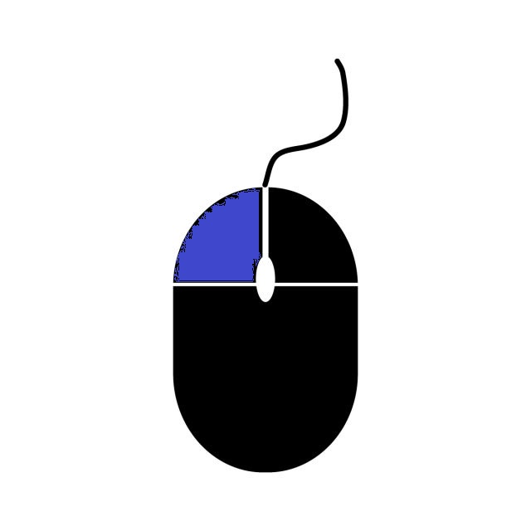
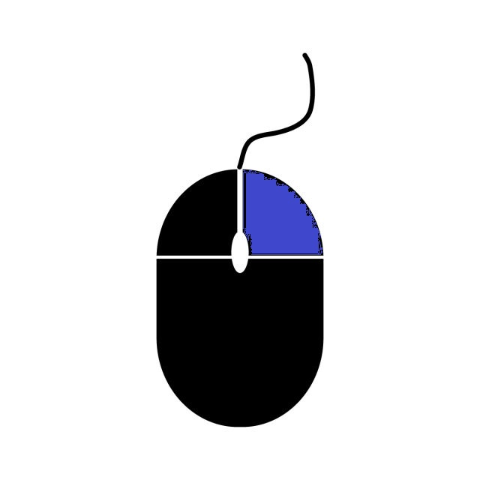
Good Luck

